OS Assigment-2 | SimpleShell: A Unix Shell in C from Scratch
Group ID-16
Members: Vaibhav Samrat Waghaye | 2024597, Rigzin Gyalpo | 2024458
Contributions:
Vaibhav-> Implemented trim() function, addToHistory() function, parseInput() function and Partial work on main() function.
Rigzin-> Implemented main() function and launch() function process creation, pipes, exec calls, timing etc.

Implementation:
Our SimpleShell was created in C using the standard Unix process management system calls.
Basically the shell runs in an infinite loop. It displays a prompt, takes input from the user, and then processes that input.
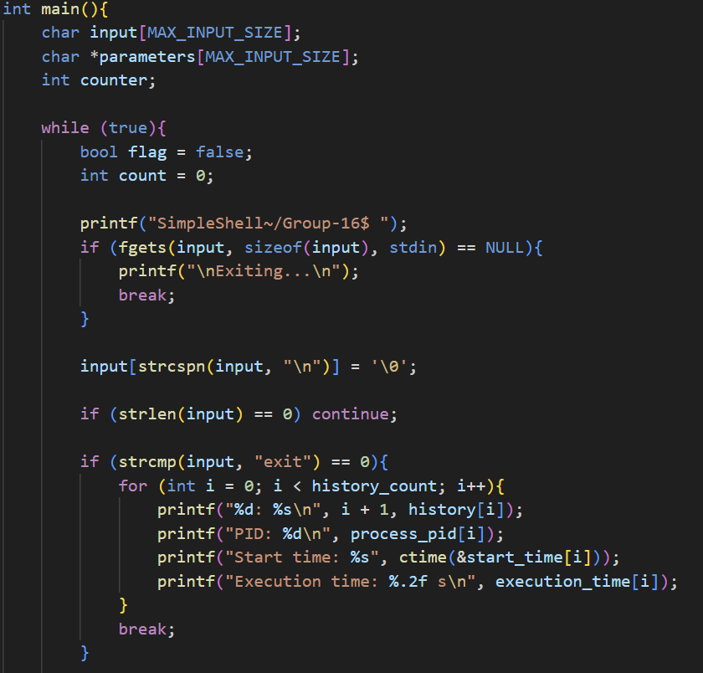
First, it trims unnecessary whitespace from the input string we made a function for this and also saves it in history. The input is then broken down into command and arguments, which are sent to an execution routine.
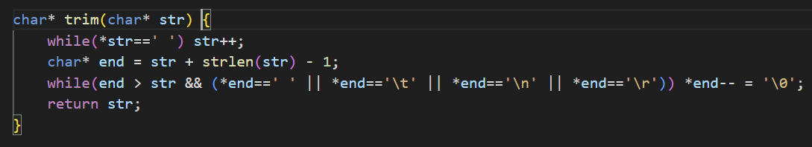
The execution uses the fork() and execvp() system calls. The parent process waits for the child process to finish before continuing. History is being kept in memory which has a fixed size and stores the command text, process ID, start time, and execution time for each command.
When the user types history, the stored list of commands shows up. When the user types exit, the shell ends and prints the details of all commands run during the session, including PID, start time, and execution duration.
We use proper error checking during system calls to handle invalid commands or failures smoothly.
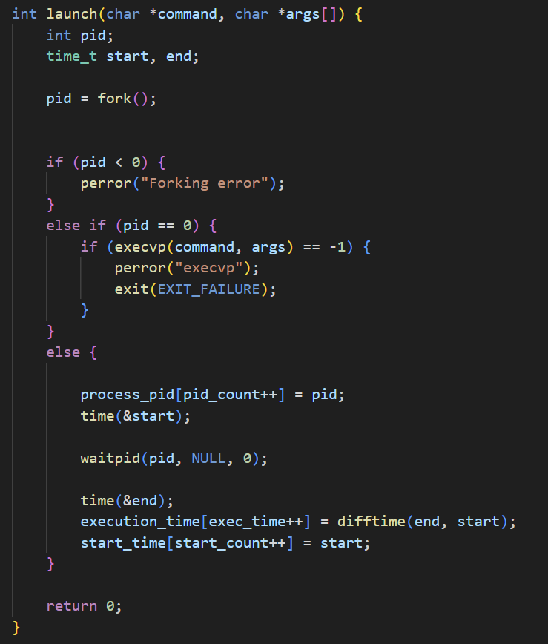

There are of course a few commands that are simple shell will not be able to run-
No Variable Substitution or Advanced Shell Features
Apart from handling exit and history, other shell built-in commands (like cd, export, alias) are unsupported.
No command substitution or scripting features like loops, conditionals, or functions.

GitHub Repository Link: https://github.com/vaibhavsw27/group-16-A2

